CpE 111 Homework Assignment #4

HW#4 will not be collected for grading since you cannot be given a week to get it done.

1. Compute the unknown quantities for each situation.

(a) I = 100mA, V=2.5v, P=?
(b) V=5v, I=0.5A, P=?
(c) P=12W, V=6v, I=?

2. An inverter (NOT) gate is designed with t_{HL}=0.25ns and t_{LH}=0.5ns. The input voltage V_{in} is shown in accompanying figure, and is known that the output voltage ranges from V_{out}=0v to V_{out}=5v. (15pts)

(a) Draw a waveform for V_{out}(t).
(b) What is the maximum switching frequency for this circuit, if 90% and 10% of V_{DD} are used as threshold voltage levels for logic 1 and 0, respectively? Draw a waveform of the output voltage V_{out} at this frequency.
(c) Suppose that the input is driven at twice the maximum frequency. Draw a waveform of the output voltage in this case, and explain why the gate will not operate properly.

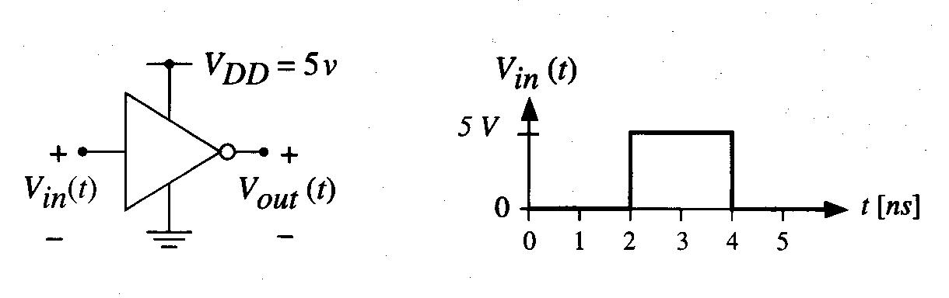

3. Calculate the delay between the input signal a(t) and the output f(t), using the following parameters: t_{p0,NOT} = 0.5ns, t_{pL,NOT} = 0.4ns, t_{p0,NOR} = 0.75ns, t_{pL,NOR} = 0.9ns, t_{p0,NAND} = 0.85ns, t_{pL,NAND} = 0.95ns. Assume that the output drives the input to one inverter.

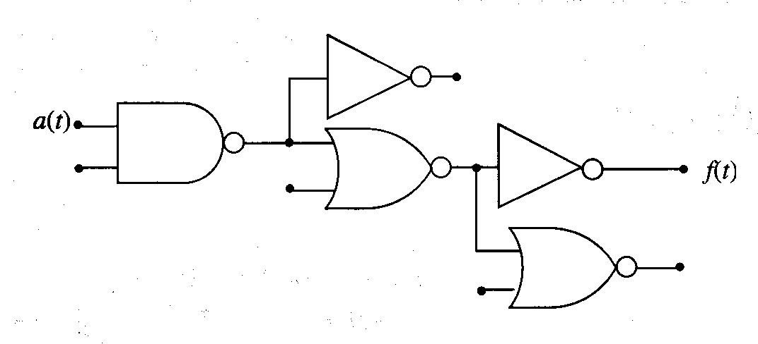

4. A capacitor of C=10μF (microfarads) has a voltage of 2v across it. Calculate the amount of charge Q, in coulombs.

5. Consider a 100fF capacitor; 1 femtofarad (fF) is equal to 10⁻¹⁵ farad. The charge Q is known to have a value of Q = 2.8nC (1nC = 10⁻⁹C). What is the voltage across the device?

6. The capacitor in an RC circuit has a value of C=10pF (picofarads). The time constant for the circuit is given as τ=7ns. Find the value R of the resistor in ohms.

7. An RC circuit is built using a resistor with a value of R=1400Ω and a capacitor that has C=5pF. (15pts)

(a) Calculate the time constant for the circuit in units of nanoseconds.
(b) Suppose that the applied voltage pulse makes a transition from 0v to 3v. What is the value of the capacitor voltage V_{C} when t= τ?
(c) Now consider the case where the capacitor voltage is at a value of 3v, and then the applied voltage is dropped to 0v. What is V_{C} when t= τ for this case?

